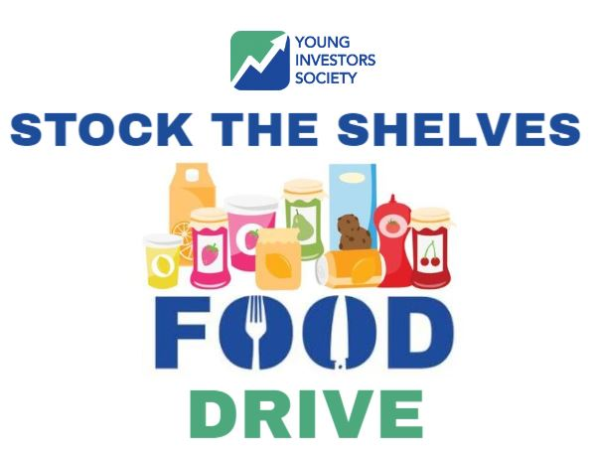

**Items Needed:**

Pasta Sauce, Canned Beans

Canned Chicken, Tuna, Spam

Canned Diced/Sliced Tomatoes

Canned Soups

Peanut Butter

Rice, Pasta, Beans

Name/logo of Food Pantry

Insert contact info for item pick up or instructions

All items will be donated to the __________Food Bank in

City/State.

Help Support the Young Investors Society Stock the Shelves Food Drive today!

Help those in need in our local community!

Accepting Non-Expired Canned Goods and Non-Perishable Food Items

JAN

1-30